Mental Health Resources

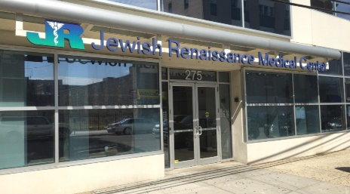
Jewish Renaissance Center accepts Medicaid, Third Party Insurance, and sliding scale 275 Hobart Street 732-376-9333

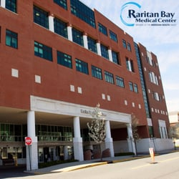
Raritan Bay Mental Health accepts Medicaid & private insurance 530 New Brunswick Avenue 732-442-3700
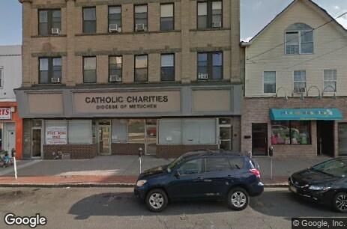
Catholic Charities accepts Medicaid, Third Party Insurance, and sliding scale 271 Smith Street 732-826-9160

Perform Care & Mobile Response Can be used with or without Insurance 877-652-7624 24hours / 7 days a week Delivers services in the home when child is exhibiting escalating behavior.

