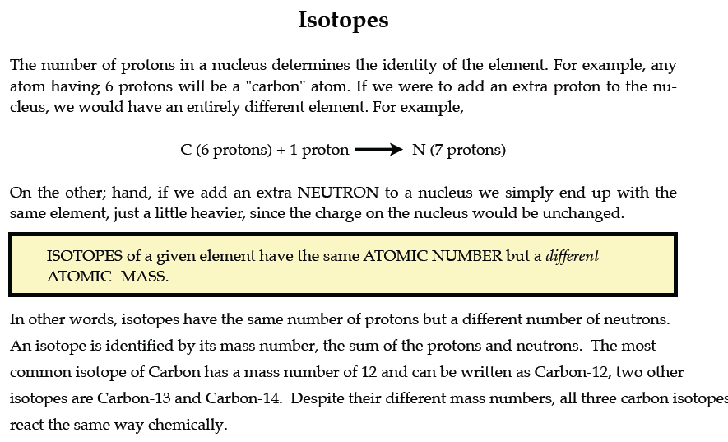
PART I. Answer the questions based on the above reading.

1. What is an isotope? Isotopes are versions of the same element. They have the same number of protons and electrons as the element but different mass numbers and number of neutrons.

2. What does the number next to isotopes signify? The number indicates the isotope’s mass number.

3. How can you tell isotopes of the same element apart? They will have a different mass number and different number of neutrons.

PART II. For each of the following isotopes, write the number of protons, neutrons, and electrons. Assume all atoms are neutral.
 | Carbon-12 | Carbon-13 | Carbon-14
# of protons | 6 | 6 | 6
# of neutrons | 6 | 7 | 8
# of electrons | 6 | 6 | 6
 | Chromium-58 | Chromium-63
# of protons | 24 | 24
# of neutrons | 34 | 39
# of electrons | 24 | 24

 | Nitrogen-15 | Nitrogen-20
# of protons | 7 | 7
# of neutrons | 8 | 13
# of electrons | 7 | .  7

 | Sulfur-23 | Sulfur-25
# of protons | 16 | 16
# of neutrons | 7 | 18
# of electrons | 16 | 16

 | Selenium-50 | Selenium-55
# of protons | 16 | 16
# of neutrons | 34 | 39
# of electrons | 16 | 16
 | Sodium-12 | Sodium-20
# of protons | 11 | 11
# of neutrons | 1 | 9
# of electrons | 11 | 11

PART III. Fill in the isotope names and any missing information on the chart. Use your periodic table and the information provided. Assume all atoms are neutral.

 | Manganese-42 (25 +17) | Manganese- -40
# of protons | 25 | 25
# of neutrons | 17 | 15
# of electrons | 25 | 25

 | Germanium-62 | Germanium-64
# of protons | 32 | 32
# of neutrons | 30 | 32
# of electrons | 32 | 32
 | Palladium- 94 | Palladium-97
# of protons | 46 | 46
# of neutrons | 48 | 51
# of electrons | 46 | 46
 | Cesium- 168 | Cesium-166
# of protons | 55 | 55
# of neutrons | 113 | 111
# of electrons | 55 | 55
 | Iron-53 | Iron-56
# of protons | 26 | 26
# of neutrons | 27 | 30
# of electrons | 26 | 26
 | Iodine-85 | Iodine-88
# of protons | 53 | 53
# of neutrons | 32 | 35
# of electrons | 53 | 53

 | Germanium-65 | Germanium-68
# of protons | 32 | 32
# of neutrons | 33 | 36
# of electrons | 32 | 32
 | Carbon -10 | Carbon -12
# of protons | 6 | 6
# of neutrons | 4 | 6
# of electrons | 6 | 6
 | Chromium -54 | Chromium -56
# of protons | 24 | 24
# of neutrons | 30 | 32
# of electrons | 24 | 24
 | Titanium -22 | Titanium -25
# of protons | 11 | 11
# of neutrons | 11 | 14
# of electrons | 11 | 11

