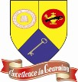
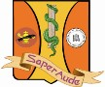

PERTH AMBOY HIGH SCHOOL

Summer Reading

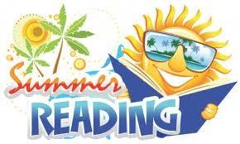

Learning is a continual process and should not be put on hold during the summer. Summer reading is widely recognized as an effective method of keeping students engaged in the learning process throughout the summer. Students and parents should identify the class level of English or ESL they will be taking in the following table of contents. The attached assignments are intended to provide students with the guidance necessary to thoughtfully read and consider the summer reading selections.

Table of Contents
English I CP Page 2
English I Honors Page 6
English II & II CP Page 7
English II Honors Page 11
English III CP – Communications Academy Page 13
English III CP Page 14
English III Honors- Communications Academy Page 18
English III Honors Page 19
English IV CP Page 20
English IV Honors Page 24
AP Literature Page 25
AP Language Page 30
English as a Second Language (ESL) Page 36

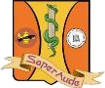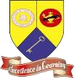

PERTH AMBOY HIGH SCHOOL
300 Eagle Avenue ~ Perth Amboy, New Jersey 08861
732-376-6030 (voice) ~ 732-347-8930 (facsimile)

English I CP

Reading is one very important way to increase reading skills and academic achievement. All students enrolled in an English class will have required summer reading.

Students should choose 1 of the following books. Students are required to read the book and write an essay that addresses the Summer Reading Prompt. The essay is due to the Language Arts teacher at the beginning of the school year.

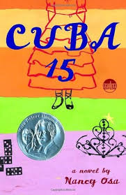
Cuba 15 by Nancy Osa
Violet Paz has just turned 15, a pivotal birthday in the eyes of her Cuban grandmother. Fifteen is the age when a girl enters womanhood, traditionally celebrating the occasion with a quinceañero. But while Violet is half Cuban, she’s also half Polish, and more importantly, she feels 100% American. Except for her zany family’s passion for playing dominoes, smoking cigars, and dancing to Latin music, Violet knows little about Cuban culture, nada about quinces, and only tidbits about the history of Cuba. So when Violet begrudgingly accepts Abuela’s plans for a quinceañero–and as she begins to ask questions about her Cuban roots–cultures and feelings collide. The mere mention of Cuba and Fidel Castro elicits her grandparents’ sadness and her father’s anger. Only Violet’s aunt Luz remains open-minded. With so many divergent views, it’s not easy to know what to believe. All Violet knows is that she’s got to form her own opinions, even if this jolts her family into unwanted confrontations.

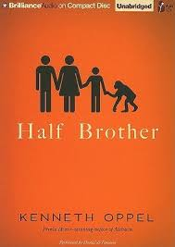
Half Brother by Kenneth Oppel
For thirteen years, Ben Tomlin was an only child. But all that changes when his mother brings home Zan — an eight-day-old chimpanzee. Ben’s father, a renowned behavioral scientist, has uprooted the family to pursue his latest research project: a high-profile experiment to determine whether chimpanzees can acquire advanced language skills. Ben’s parents tell him to treat Zan like a little brother. Ben reluctantly agrees. At least now he’s not the only one his father’s going to scrutinize. It isn’t long before Ben is Zan’s favorite, and Ben starts to see Zan as more than just an experiment. His father disagrees. Soon Ben is forced to make a critical choice between what he is told to believe and what he knows to be true — between obeying his father or protecting his brother from an unimaginable fate.

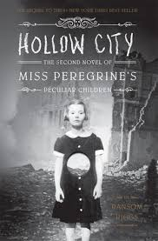
Hollow City by Ransom Riggs
Having escaped Miss Peregrine’s island by the skin of their teeth, Jacob and his new friends must journey to London, the peculiar capital of the world. Along the way, they encounter new allies, a menagerie of peculiar animals, and other unexpected surprises.

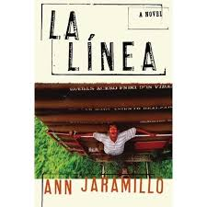
La Linea by Ann Jaramillo
Miguel's life is just beginning. Or so he thinks. Fifteen-year-old Miguel leaves his rancho deep in Mexico to migrate to California across la linea, the border. But Miguel's carefully laid plans change suddenly when his younger sister Elena stows away and follows him. Together, Miguel and Elena endure hardships and danger on their journey of desperation and desire, loyalty and betrayal.

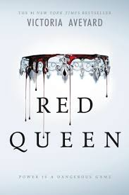
Red Queen by Victoria Aveyard
This is a world divided by blood - red or silver. The Reds are commoners, ruled by a Silver elite in possession of god-like superpowers. And to Mare Barrow, a seventeen-year-old Red girl from the poverty-stricken Stilts, it seems like nothing will ever change. That is until she finds herself working in the Silver Palace. Here, surrounded by the people she hates the most, Mare discovers that, despite her red blood, she possesses a deadly power of her own. One that threatens to destroy the balance of power. This is the first book of the series.

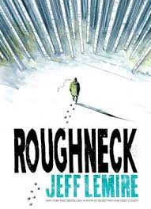
Roughneck by Jeff Lemire
A graphic novel about a brother and sister who must come together after years apart to face the disturbing history that has cursed their family. Derek Ouellette’s glory days are behind him. His hockey career ended a decade earlier in a violent incident on ice, and since then he’s been living off his reputation in the remote northern community where he grew up, drinking too much and fighting anyone who crosses him. When his long-lost sister Beth shows up, on the run from an abusive boyfriend, the two escape to a secluded hunting camp in the woods. There, living off the land, they reconnect with each other, the painful secrets of their past, and their Cree heritage...and start to heal. But Beth’s ex-boyfriend is hunting them. As he circles closer, he threatens to shatter this newfound peace and pull both Derek and Beth back into the world of self-destruction they’ve fought so hard to leave behind.

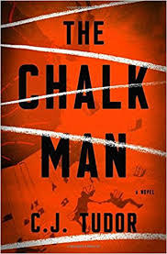
The Chalk Man by C.J. Tudor
It began back in 1986, at the fair, on the day of the accident. That was when twelve-year-old Eddie met Mr Halloran - the Chalk Man. He gave Eddie the idea for the drawings: a way to leave secret messages for his friends and it was fun, until the chalk men led them to a body. Thirty years later, Ed believes the past is far behind him, until an envelope slips through the letterbox. It contains a stick of chalk, and a drawing of a figure.

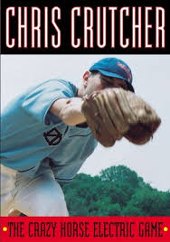
The Crazy Horse Electric Game by Chris Crutcher
Willie Weaver used to be a hero - the top athlete, the star of the legendary game against Crazy Horse Electric. Then a freak accident robs him of his once-amazing physical talents. Betrayed by his family, his girlfriend, and his own body, Willie's on the run, penniless and terrified on the streets, where he must fight to rebuild both his body and his life.

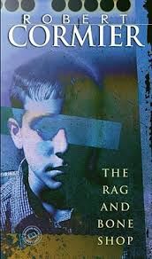
The Rag and Bone Shop by Robert Cormier
Jason, almost 13, is a shy, ineffectual child, who takes being bullied as a matter of course--but if he sees someone else being pushed around, he may strike back. When the seven-year-old girl who lives next door is murdered, Jason is horrified. He was the last one to see her alive. He wants to do everything he can to help find the killer, so when the police come calling, he tells them all he knows. What he doesn't know is that Trent, a detective adept at extracting confessions, has been called into the case--and Trent has Jason in his sights as the murderer.

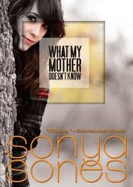
What Mother Doesn’t Know by Sonya Sones
This free verse novel follows ninth-grader Sophie Stein as she struggles through the daily grind of being a freshman in high school, her romantic crushes and family life.

Summer Reading Prompt

Write or type a 300-500 word essay in which you identify and support a claim about a character or theme in the book. Support your claim with valid reasons and evidence from the book.

In your writing make sure you:

- Write an introduction that engages the reader
- Organize your writing into logical paragraphs
- Clearly state your central idea or claim
- Give reasons for your central idea or claim
- Provide textual evidence to support your ideas
- Use transition words or phrases to connect your ideas
- Write a conclusion that summarizes your main points

PERTH AMBOY HIGH SCHOOL
300 Eagle Avenue ~ Perth Amboy, New Jersey 08861
732-376-6030 (voice) ~ 732-347-8930 (facsimile)

English I Honors

Reading is one very important way to increase reading skills and academic achievement. All students enrolled in an English class will have required summer reading.

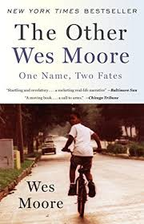
Students will read The Other Wes Moore by Wes Moore and choose 1 book from the English I and I CP list. Students are required to read the two books and write an essay for each book that addresses the Summer Reading Prompt. The essays are due to the Language Arts teacher at the beginning of the school year.

Summer Reading Prompt

Write or type two 300-500 word essays in which you identify and support a claim about a character or theme in each book. Support your claim with valid reasons and evidence from the book.

In your writing make sure you:

- Write an introduction that engages the reader
- Organize your writing into logical paragraphs
- Clearly state your central idea or claim
- Give reasons for your central idea or claim
- Provide textual evidence to support your ideas
- Use transition words or phrases to connect your ideas
- Write a conclusion that summarizes your main points

PERTH AMBOY HIGH SCHOOL
300 Eagle Avenue ~ Perth Amboy, New Jersey 08861
732-376-6030 (voice) ~ 732-347-8930 (facsimile)

English II and English II CP

Reading is one very important way to increase reading skills and academic achievement. All students enrolled in an English class will have required summer reading.

Students should choose 1 of the following books. Students are required to read the book and write an essay that addresses the Summer Reading Prompt. The essay is due to the Language Arts teacher at the beginning of the school year.

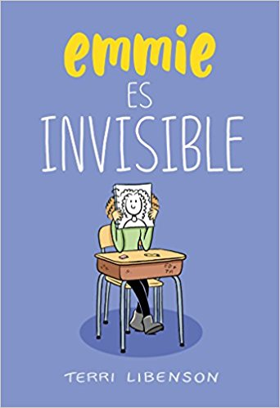
Emmie es Invisible by Terri Libenson
Una novela gráfica que te robará el corazón. Emmie es creativa, alegre pero extremadamente tímida.
Katie es muy popular, algo atolondrada y llena de energía. Emmie y Katie son muy diferentes pero, cuando una notita secreta cae en las manos equivocadas, verán cómo sus vidas se unen y cambian para siempre. Todos los enamoramientos, humillaciones, aburrimientos y pequeños grandes dramas que sufrimos a los doce años, están concentradosen un solo y sorprendente día en esta extraordinaria novela gráfica sobre la amistad, la autoestima, la empatía y el compañerismo. Porque todos nos hemos sentido invisibles alguna vez...

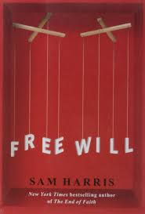
Freewill by Sam Harris
Belief in free will touches nearly everything that human beings value. It is difficult to think about law, politics, religion, public policy, intimate relationships, morality—as well as feelings of remorse or personal achievement—without first imagining that every person is the true source of his or her thoughts and actions. And yet the facts tell us that free will is an illusion. .In this enlightening book, Sam Harris argues that this truth about the human mind does not undermine morality or diminish the importance of social and political freedom, but it can and should change the way we think about some of the most important questions in life.

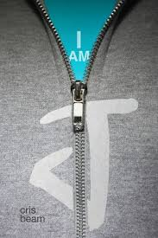
I am J by Cris Beam
"Hola, Jeni."J spun. His stomach clenched hard, as though he'd been hit. It was just the neighbor lady, Mercedes. J couldn't muster a hello back, not now; he didn't care that she'd tell his mom he'd been rude. She should know better. Nobody calls me Jeni anymore. J always felt different. He was certain that eventually everyone would understand who he really was: a boy mistakenly born as a girl. Yet as he grew up, his body began to betray him; eventually J stopped praying to wake up a "real boy" and started covering up his body, keeping himself invisible - from his family, from his friends...from the world. But after being deserted by the best friend he thought would always be by his side, J decides that he's done hiding - it's time to be who he really is. And this time he is determined not to give up, no matter the cost.

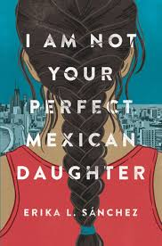
I Am Not Your Perfect Mexican Daughter by Erika L. Sanhez
Perfect Mexican daughters do not go away to college. And they do not move out of their parents’ house after high school graduation. Perfect Mexican daughters never abandon their family. But Julia is not your perfect Mexican daughter. That was Olga’s role. Then a tragic accident on the busiest street in Chicago leaves Olga dead and Julia left behind to reassemble the shattered pieces of her family. And no one seems to acknowledge that Julia is broken, too. Instead, her mother seems to channel her grief into pointing out every possible way Julia has failed. But it’s not long before Julia discovers that Olga might not have been as perfect as everyone thought. With the help of her best friend Lorena, and her first kiss, first love, first everything boyfriend Connor, Julia is determined to find out. Was Olga really what she seemed? Or was there more to her sister’s story? And either way, how can Julia even attempt to live up to a seemingly impossible ideal?

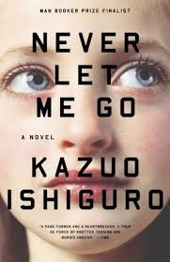
Never Let Me Go by Kazuo Ishiguro
As a child, Kathy – now thirty-one years old – lived at Hailsham, a private school in the scenic English countryside where the children were sheltered from the outside world, brought up to believe that they were special and that their well-being was crucial not only for themselves but for the society they would eventually enter. Kathy had long ago put this idyllic past behind her, but when two of her Hailsham friends come back into her life, she stops resisting the pull of memory.

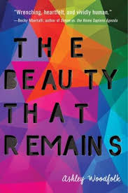
The Beauty That Remains by Ashley Woodfolk
Autumn always knew exactly who she was—a talented artist and a loyal friend. Shay was defined by two things: her bond with her twin sister, Sasha, and her love of music. And Logan always turned to writing love songs when his love life was a little less than perfect. But when tragedy strikes each of them, somehow music is no longer enough. Now Logan can’t stop watching vlogs of his dead ex-boyfriend. Shay is a music blogger struggling to keep it together. And Autumn sends messages that she knows can never be answered. Despite the odds, one band's music will reunite them and prove that after grief, beauty thrives in the people left behind.
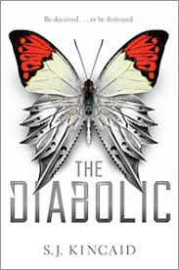
The Diabolic by S.J. Kincaid
Nemesis is a Diabolic. Created to protect a galactic Senator's daughter, Sidonia. There's no one Nemesis wouldn't kill to keep her safe. But when the power-mad Emperor summons Sidonia to the galactic court as a hostage, there is only one way for Nemesis to protect Sidonia. She must become her. Now one of the galaxy's most dangerous weapons is masquerading in a world of corruption and Nemesis has to hide her true abilities or risk everything. As the Empire begins to fracture and rebellion looms closer, Nemesis learns that there is something stronger than her deadly force: the one thing she's been told she doesn't have - humanity. And, amidst all the danger, action and intrigue, her humanity might be the only thing that can save her, Sidonia and the entire Empire. Part of a series of books.

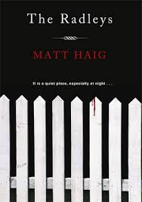
The Radley’s by Matt Haig
The Radleys are an everyday family who juggle dysfunctional lives. Except, as Peter and Helen Radley know, but their children have yet to find out, the Radleys happen to be a family of abstaining vampires. When one night Clara finds herself driven to commit a bloodthirsty act, her parents decide to explain a few things.

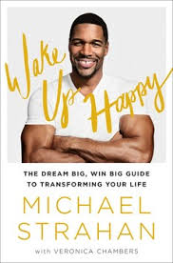
Wake Up Happy by Michael Strahan
Michael Strahan spent his childhood on a military base in Europe, where community meant everything, and life, though idyllic, was different. For one, when people referenced football they meant soccer. So when Michael’s father suggested he work toward a college scholarship by playing football in Texas, where tens of thousands of people show up for a weekend game, the odds were long. Yet he did, indeed, land a scholarship and from there a draft into the NFL where he scaled the league’s heights, broke records, and helped his team win the Super Bowl as a result of which he was inducted into the Hall of Fame. How? By developing “Strahan’s Rules”—a mix of mental discipline, positive thinking, and a sense of play. He also used the Rules to forge a successful post pro-ball career as cohost with Kelly Ripa on Live!—a position for which he was considered the longshot—and much more. In Wake Up Happy, Michael shares personal stories about how he gets and stays motivated and how readers can do the same in their quest to attain their life goals.

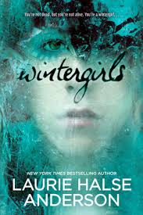
Wintergirls by Laurie Halse Anderson
Lia and Cassie are best friends, wintergirls frozen in matchstick bodies, competitors in a deadly contest to see who can be the skinniest. But what comes after size zero and size double-zero? When Cassie succumbs to the demons within, Lia feels she is being haunted by her friend’s restless spirit.

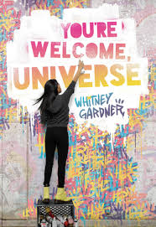
You’re Welcome, Universe by Whitney Gardner
When Julia finds a slur about her best friend scrawled across the back of the Kingston School for the Deaf, she covers it up with a beautiful (albeit illegal) graffiti mural. Her supposed best friend snitches, the principal expels her, and her two mothers set Julia up with a one-way ticket to a “mainstream” school in the suburbs, where she’s treated like an outcast as the only deaf student. The last thing she has left is her art, and not even Banksy himself could convince her to give that up. Out in the ’burbs, Julia paints anywhere she can, eager to claim some turf of her own. But Julia soon learns that she might not be the only vandal in town. Someone is adding to her tags, making them better, showing off—and showing Julia up in the process. She expected her art might get painted over by cops. But she never imagined getting dragged into a full-blown graffiti war.

Summer Reading Prompt

Write or type one 300-500 word essay in which you identify and support a claim about a character or theme in each book. Support your claim with valid reasons and evidence from the book.

In your writing make sure you:

- Write an introduction that engages the reader
- Organize your writing into logical paragraphs
- Clearly state your central idea or claim
- Give reasons for your central idea or claim
- Provide textual evidence to support your ideas
- Use transition words or phrases to connect your ideas
- Write a conclusion that summarizes your main points

PERTH AMBOY HIGH SCHOOL
300 Eagle Avenue ~ Perth Amboy, New Jersey 08861
732-376-6030 (voice) ~ 732-347-8930 (facsimile)

English II Honors

The Catcher in the Rye -J.D. Salinger

The Bell Jar – Sylvia Plath
In order to prepare you for this year, you will be reading two novels: The Catcher in the Rye by J.D. Salinger and The Bell Jar by Sylvia Plath.

In addition to reading both novels, please complete the following assignments:
- Double Journal Entries - For each novel you are to complete a double entry journal. In order to complete this activity you must identify and analyze quotes that represent the following topics: identity, alienation and loneliness, and adolescence.

  - Divide your papers into two columns. In the left column, copy three passages from each book pertaining to each of the three themes. In the right column, write a paragraph analyzing what that passage illustrates about the themes you’ve been asked to consider. Each analysis should be a minimum of 5 sentences.
  - You need a total of nine quotes for each novel (three per topic x two novels).
  - Cite each quotation properly (author’s last name #).
  - You must use formal tone – NO “I”, “me”, “you”, etc.
  - These journals must be typed and a hard copy must be submitted on the first day of school, unless told otherwise.

- Writing Assignment – Using Catcher in the Rye and The Bell Jar, compose two well-written essays that address the following points:
  - the search for social identity
  - alienation and loneliness

As you write, keep in the mind the following:
  - Make sure you use direct evidence, i.e. quotes, from each of the novels in your essay. Use quotes to support your arguments. When you use quotes, always reference the page number.
  - Do not start a paragraph with a quote from the novel(s).
  - Your paper should be at least 2 pages in length (12 point font and double-spaced)
  - Papers should be typed and hard copies must be submitted on the first day of school, unless told otherwise.

Dialectical Journal

Name:____________________________________________________ Date:________________________

Text Title: Author:
Reference to the Text  In the space below, copy direct quotations, key words, details, and/or summaries from the text that stand out to you. Make sure to include the author’s last name followed by the page number in parentheses. | Your Response or Interpretation  Write a response to the quote. Your response should include these three parts:  - Context - What’s happening at this point in the passage?  - Summary - What does the quote mean?  - Significance - Why is the quote important to the passage? Why does it stand out to you?

PERTH AMBOY HIGH SCHOOL
300 Eagle Avenue ~ Perth Amboy, New Jersey 08861
732-376-6030 (voice) ~ 732-347-8930 (facsimile)

English III CP- Communications Academy

Reading is one very important way to increase reading skills and academic achievement. All students enrolled in an English class will have required summer reading.

Students will read the following book. Students are required to read the book and write an essay that addresses the Summer Reading Prompt. The essay is due to the Language Arts teacher at the beginning of the school year.

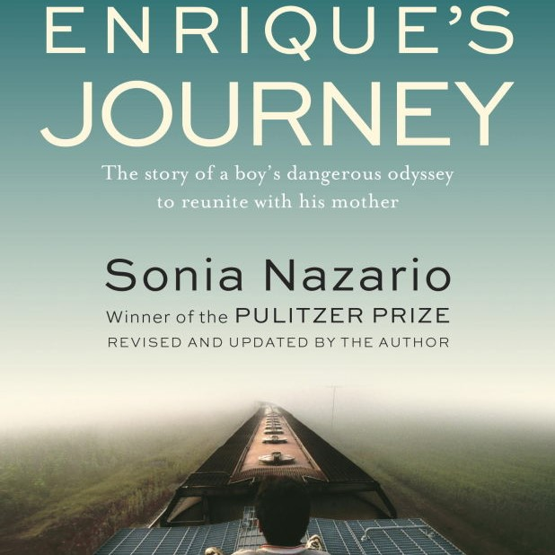
Enrique’s Journey recounts the unforgettable quest of a Honduran boy looking for his mother, eleven years after she is forced to leave her starving family to find work in the United States. Braving unimaginable peril, often clinging to the sides and tops of freight trains, Enrique travels through hostile worlds full of thugs, bandits, and corrupt cops. But he pushes forward, relying on his wit, courage, hope, and the kindness of strangers. As Isabel Allende writes: “This is a twenty-first-century Odyssey. If you are going to read only one nonfiction book this year, it has to be this one.”
Summer Reading Prompt

Write or type one 300-500 word essay in which you identify and support a claim about a character or theme in each book. Support your claim with valid reasons and evidence from the book.

In your writing make sure you:

- Write an introduction that engages the reader
- Organize your writing into logical paragraphs
- Clearly state your central idea or claim
- Give reasons for your central idea or claim
- Provide textual evidence to support your ideas
- Use transition words or phrases to connect your ideas
- Write a conclusion that summarizes your main points

PERTH AMBOY HIGH SCHOOL
300 Eagle Avenue ~ Perth Amboy, New Jersey 08861
732-376-6030 (voice) ~ 732-347-8930 (facsimile)

English III CP

Reading is one very important way to increase reading skills and academic achievement. All students enrolled in an English class will have required summer reading.

Students should choose 1 of the following books. Students are required to read the book and write an essay that addresses the Summer Reading Prompt. The essay is due to the Language Arts teacher at the beginning of the school year.

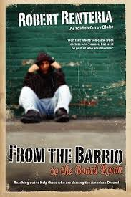
From the Barrio to the Boardroom by Robert Renteria
"Don't let where you came from dictate who you are, but let it be part of who you become." These are the words of successful entrepreneur Robert Renteria, who today is Executive Vice President/Co-Founder of WashPro USA, but who grew up as an infant sleeping in a dresser drawer. This poignant and often hard-hitting memoir traces Robert's life from a childhood of poverty and abuse in one of the poorest areas of East Los Angeles, to his proud emergence as a business owner today. Along the way, Robert paints a vivid portrait of the numerous people who influenced his life, both good and bad - on one side, his loving and supportive mother, who always believed in him; and the US Army, which showed him that persistence, respect, integrity, commitment and honor could lead to great rewards. On the other side, he talks about the forces that dragged him down - gangs; doing and dealing drugs, an alcohol and drug addicted father that abandoned the family, a sometimes abusive stepfather and climbing the broken ladder of corporate America.

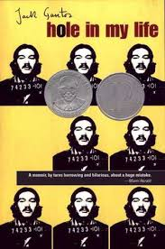
Hole in My Life by Jack Gantos
In the summer of 1971, Jack Gantos was an aspiring writer looking for adventure, cash for college tuition, and a way out of a dead-end job. For ten thousand dollars, he recklessly agreed to help sail a sixty-foot yacht loaded with a ton of hashish from the Virgin Islands to New York City, where he and his partners sold the drug until federal agents caught up with them. For his part in the conspiracy, Gantos was sentenced to serve up to six years in prison.

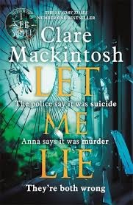
Let Me Lie by Clare Mackintosh
Anna Johnson’s parents committed suicide within months of each other, but were the deaths really suicide? An anonymous note sends Anna on the trail of the truth, drawing retired detective into the hunt but then attempting to retreat when it looks like finding the killer will mean exposing family secrets. Mackintosh’s three bar-raising psychological thrillers have proven her adept at crafting compellingly flawed, authority-bucking characters and creating twists from the ripple effects of their relationships and personal issues.

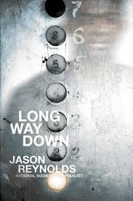
Long Way Down by Jason Reynolds
Fifteen-year-old Will has shoved a gun in the back waistband of his jeans. See, his brother Shawn was just murdered. And Will knows the rules. No crying. No snitching. Revenge. That’s where Will’s now heading, with that gun shoved in the back waistband of his jeans, the gun that was his brother’s gun. He gets on the elevator, seventh floor, stoked. He knows who he’s after. Or does he?

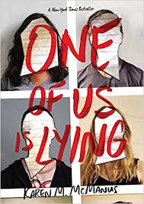
One of Us is Lying by Karen M. McManus
On Monday afternoon, five students at Bayview High walk into detention. Bronwyn, the brain, is Yale-bound and never breaks a rule. Addy, the beauty, is the picture-perfect homecoming princess. Nate, the criminal, is already on probation for dealing. Cooper, the athlete, is the all-star baseball pitcher. And Simon, the outcast, is the creator of Bayview High's notorious gossip app. Only, Simon never makes it out of that classroom. Before the end of detention, Simon's dead. And according to investigators, his death wasn't an accident.

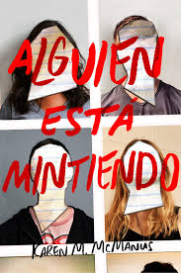
Alguien Esta Mintiendo by Karen M. McManus
Una nueva app está acorralando a la élite del instituto Bayview para estudiantes de perfil elevado. Las filtraciones de la vida privada de los estudiantes corren como la pólvora por la nueva red social creada por Simon Kelleher, alumno de la misma institución. Pero la cosa se pone muy seria cuando Simon es asesinado justo delante de sus víctimas. Los cuatro cabecillas de la «crème de la crème» estudiantil se convierten en sospechosos directos del asesinato.

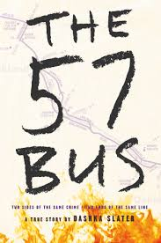
The 57 Bus: A True Story of Two Teenagers and the Crime That Changed Their Lives by Dashka Slater
If it weren't for the 57 bus, Sasha and Richard never would have met. Both were high school students from Oakland, California, one of the most diverse cities in the country, but they inhabited different worlds. Sasha, a white teen, lived in the middle-class foothills and attended a small private school. Richard, a black teen, lived in the crime-plagued flatlands and attended a large public one. Each day, their paths overlapped for a mere eight minutes. But one afternoon on the bus ride home from school, a single reckless act left Sasha severely burned, and Richard charged with two hate crimes and facing life imprisonment.

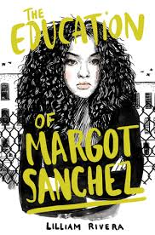
The Education of Margot Sanchez by Lillian Rivera
Pretty in Pink comes to the South Bronx in this bold and romantic coming-of-age novel about dysfunctional families, good and bad choices, and finding the courage to question everything you ever thought you wanted.

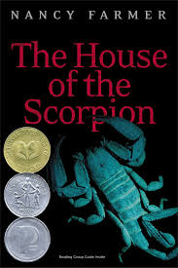
The House of the Scorpion by Nancy Farmer
At his coming-of-age party, Matteo Alacrán asks El Patrón's bodyguard, "How old am I?...I know I don't have a birthday like humans, but I was born." "You were harvested," Tam Lin reminds him. "You were grown in that poor cow for nine months and then you were cut out of her." To most people around him, Matt is not a boy, but a beast. A room full of chicken litter with roaches for friends and old chicken bones for toys is considered good enough for him. But for El Patrón, lord of a country called Opium -- a strip of poppy fields lying between the U.S. and what was once called Mexico -- Matt is a guarantee of eternal life. El Patrón loves Matt as he loves himself for Matt is himself. They share identical DNA.

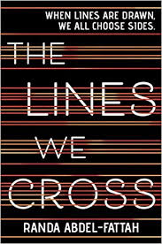
The Lines We Cross by Randa Abdel-Fattah
Michael likes to hang out with his friends and play with the latest graphic design software. His parents drag him to rallies held by their anti-immigrant group, which rails against the tide of refugees flooding the country. And it all makes sense to Michael. Until Mina, a beautiful girl from the other side of the protest lines, shows up at his school, and turns out to be funny, smart—and a Muslim refugee from Afghanistan. Suddenly, his parents’ politics seem much more complicated. Mina has had a long and dangerous journey fleeing her besieged home in Afghanistan, and now faces a frigid reception at her new prep school, where she is on scholarship. As tensions rise, lines are drawn. Michael has to decide where he stands. Mina has to protect herself and her family. Both have to choose what they want their world to look like.

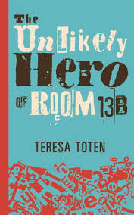
The Unlikely Hero of Room 13B by Teresa Toten
When Adam meets Robyn at a support group for kids coping with obsessive-compulsive disorder, he is drawn to her almost before he can take a breath. He's determined to protect and defend her--to play Batman to her Robyn--whatever the cost. But when you're fourteen and the everyday problems of dealing with divorced parents and step-siblings are supplemented by the challenges of OCD, it's hard to imagine yourself falling in love. How can you have a "normal" relationship when your life is so fraught with problems? And that's not even to mention the small matter of those threatening letters Adam's mother has started to receive.

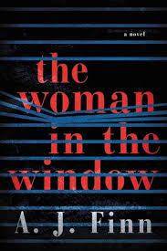
The Woman in the Window by A.J. Finn
Anna Fox lives alone—a recluse in her New York City home, unable to venture outside. She spends her day drinking wine (maybe too much), watching old movies, recalling happier times . . . and spying on her neighbors. Then the Russells move into the house across the way: a father, a mother, their teenage son. The perfect family. But when Anna, gazing out her window one night, sees something she shouldn’t, her world begins to crumble—and its shocking secrets are laid bare. What is real? What is imagined? Who is in danger? Who is in control? In this diabolically gripping thriller, no one—and nothing—is what it seems.

Summer Reading Prompt

Write or type one 300-500 word essay in which you identify and support a claim about a character or theme in each book. Support your claim with valid reasons and evidence from the book.

In your writing make sure you:

- Write an introduction that engages the reader
- Organize your writing into logical paragraphs
- Clearly state your central idea or claim
- Give reasons for your central idea or claim
- Provide textual evidence to support your ideas
- Use transition words or phrases to connect your ideas
- Write a conclusion that summarizes your main points

PERTH AMBOY HIGH SCHOOL
300 Eagle Avenue ~ Perth Amboy, New Jersey 08861
732-376-6030 (voice) ~ 732-347-8930 (facsimile)

English III Honors - Communications Academy

Blindness by Jose Saramago

Amercanah by Chimamanda Ngozi Adichie

In order to prepare you for this year, you will be reading two novels: Blindness by Saramago and Amercanah by Adichie

Writing Assignment
Type two essays in which you identify and support a claim pertaining to a theme in one book and a character in the other book. Support your claim with valid reasons and evidence from the book.

As you write, keep in the mind the following:
  - Make sure you use direct evidence, i.e. quotes, from each of the novels in your essay. Use quotes to support your arguments. When you use quotes, always reference the page number.
  - Do not start a paragraph with a quote from the novel(s).
  - Your paper should be at least 2 pages in length (12 point font and double-spaced)
  - Papers should be typed and hard copies must be submitted on the first day of school, unless told otherwise.

PERTH AMBOY HIGH SCHOOL
300 Eagle Avenue ~ Perth Amboy, New Jersey 08861
732-376-6030 (voice) ~ 732-347-8930 (facsimile)

English III Honors

Blindness by Jose Saramago

Beloved by Toni Morrison

In order to prepare you for this year, you will be reading two novels: Blindness by Jose Saramago and Beloved by Toni Morrison.

Writing Assignment
Type two essays in which you identify and support a claim pertaining to a theme in one book and a character in the other book. Support your claim with valid reasons and evidence from the book.

As you write, keep in the mind the following:
  - Make sure you use direct evidence, i.e. quotes, from each of the novels in your essay. Use quotes to support your arguments. When you use quotes, always reference the page number.
  - Do not start a paragraph with a quote from the novel(s).
  - Your paper should be at least 2 pages in length (12 point font and double-spaced)
  - Papers should be typed and hard copies must be submitted on the first day of school, unless told otherwise.

PERTH AMBOY HIGH SCHOOL
300 Eagle Avenue ~ Perth Amboy, New Jersey 08861
732-376-6030 (voice) ~ 732-347-8930 (facsimile)

English IV CP

Reading is one very important way to increase reading skills and academic achievement. All students enrolled in an English class will have required summer reading.

Students should choose 1 of the following books. Students are required to read the book and write an essay that addresses the Summer Reading Prompt. The essay is due to the Language Arts teacher at the beginning of the school year.

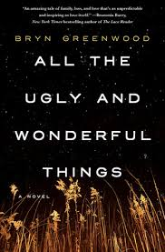
All the Ugly and Wonderful Things by Bryn Greenwood
A beautiful and provocative love story between two unlikely people and the hard-won relationship that elevates them above the Midwestern meth lab backdrop of their lives. As the daughter of a drug dealer, Wavy knows not to trust people, not even her own parents. It's safer to keep her mouth shut and stay out of sight. Struggling to raise her little brother, Donal, eight-year-old Wavy is the only responsible adult around. Obsessed with the constellations, she finds peace in the starry night sky above the fields behind her house, until one night her star gazing causes an accident. After witnessing his motorcycle wreck, she forms an unusual friendship with one of her father's thugs, Kellen, a tattooed ex-con with a heart of gold. By the time Wavy is a teenager, her relationship with Kellen is the only tender thing in a brutal world of addicts and debauchery. When tragedy rips Wavy's family apart, a well-meaning aunt steps in, and what is beautiful to Wavy looks ugly under the scrutiny of the outside world.

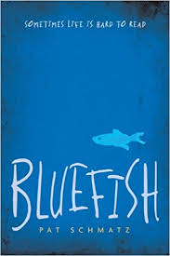
Bluefish by Pat Schmatz
Travis is missing his old home in the country, and he’s missing his old hound, Rosco. Now there’s just the cramped place he shares with his alcoholic grandpa, a new school, and the dreaded routine of school. But that’s before Travis meets Mr. McQueen, who doesn’t take "pass" for an answer—a rare teacher whose savvy persistence has Travis slowly unlocking a book on the natural world. And it’s before Travis is noticed by Velveeta, a girl whose wry banter and colorful scarves belie some hard secrets of her own. With sympathy, humor, and disarming honesty, Pat Schmatz brings to life a cast of utterly believable characters—and captures the moments of trust and connection that make all the difference.

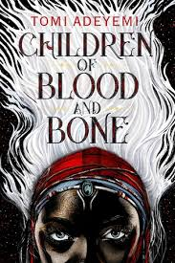
Children of Blood and Bone by Tomi Adeyemi
Zélie Adebola remembers when the soil of Orïsha hummed with magic. Burners ignited flames, Tiders beckoned waves, and Zelie’s Reaper mother summoned forth souls. But everything changed the night magic disappeared. Under the orders of a ruthless king, maji were targeted and killed, leaving Zélie without a mother and her people without hope. Now, Zélie has one chance to bring back magic and strike against the monarchy. With the help of a rogue princess, Zélie must outwit and outrun the crown prince, who is hell-bent on eradicating magic for good. Danger lurks in Orïsha, where snow leoponaires prowl and vengeful spirits wait in the waters. Yet the greatest danger may be Zélie herself as she struggles to control her powers—and her growing feelings for the enemy. A book in a series.

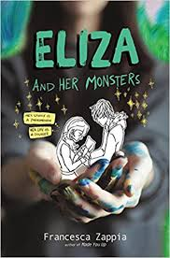
Eliza and Her Monsters by Francesca Zappia
In the real world, Eliza Mirk is shy, weird, and friendless. Online, she’s LadyConstellation, the anonymous creator of the wildly popular webcomic Monstrous Sea. Eliza can’t imagine enjoying the real world as much as she loves the online one, and she has no desire to try. Then Wallace Warland, Monstrous Sea’s biggest fanfiction writer, transfers to her school. Wallace thinks Eliza is just another fan, and as he draws her out of her shell. She begins to wonder if a life offline might be worthwhile. But when Eliza’s secret is accidentally shared with the world, everything she’s built—her story, her relationship with Wallace, and even her sanity—begins to fall apart.

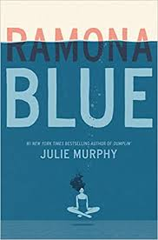
Ramona Blue by Julie Murphy
Ramona was only five years old when Hurricane Katrina changed her life forever. Since then, it’s been Ramona and her family against the world. Standing over six feet tall with unmistakable blue hair, Ramona is sure of three things: she likes girls, she’s fiercely devoted to her family, and she knows she’s destined for something bigger than the trailer she calls home in Eulogy, Mississippi. But juggling multiple jobs, her flaky mom, and her well-meaning but ineffectual dad forces her to be the adult of the family. Now, with her sister, Hattie, pregnant, responsibility weighs more heavily than ever. The return of her childhood friend Freddie brings a welcome distraction. Ramona’s friendship with the former competitive swimmer picks up exactly where it left off, and soon he’s talked her into joining him for laps at the pool. But as Ramona falls in love with swimming, her feelings for Freddie begin to shift too, which is the last thing she expected. With her growing affection for Freddie making her question her sexual identity, Ramona begins to wonder if perhaps she likes girls and guys or if this new attraction is just a fluke. Either way, Ramona will discover that, for her, life and love are more fluid than they seem.

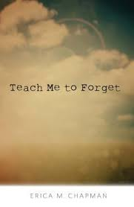
Teach Me to Forget by Erica M. Chapman
Ellery's bought the gun, made arrangements for her funeral, and even picked the day. A Wednesday. Everything has fallen into place. Now all she has to do is die. When her plans go awry and the gun she was going to kill herself with breaks, she does the one thing she has control over--return it and get a new one. After tormenting the crusty customer service associate by trying to return the gun with the wrong receipt, Ellery gets caught by the security guard who also happens to be someone she knows--the annoyingly perfect Colter Sawyer from her English class. Colter quickly uncovers what she's hiding and is determined to change her mind. After confessing a closely held secret of his own, he promises not to tell hers. Ellery tries to fight her attraction to him as the shadows of her past cling tight around her, but when she's faced with another tragedy, she must decide whether she can learn to live with what she's done or follow through with her plan to die.

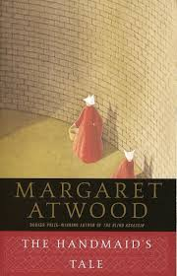
The Handmaid’s Tale by Margaret Atwood
Offred is a Handmaid in the Republic of Gilead. She may leave the home of the Commander and his wife once a day to walk to food markets whose signs are now pictures instead of words because women are no longer allowed to read. She must lie on her back once a month and pray that the Commander makes her pregnant, because in an age of declining births, Offred and the other Handmaids are valued only if their ovaries are viable. Offred can remember the years before, when she lived and made love with her husband, Luke; when she played with and protected her daughter; when she had a job, money of her own, and access to knowledge. But all of that is gone now...

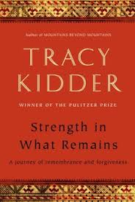
Strength in What Remains by Tracy Kidder
Deo arrives in America from Burundi in search of a new life. Having survived a civil war and genocide, plagued by horrific dreams, he lands at JFK airport with two hundred dollars, no English, and no contacts. He ekes out a precarious existence delivering groceries, living in Central Park, and learning English by reading dictionaries in bookstores. Then Deo begins to meet the strangers who will change his life, pointing him eventually in the direction of Columbia University, medical school, and a life devoted to healing. Kidder breaks new ground in telling this unforgettable story as he travels with Deo back over a turbulent life in search of meaning and forgiveness.

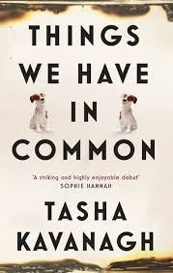
Things We Have in Common by Tasha Kavanagh
Fifteen‐year‐old Yasmin Doner is a social misfit—obese, obsessive and deemed a freak by her peers at school. With her father dead and her mother in a new relationship, Yasmin yearns for a sense of belonging, finding comfort only in food and the fantasy of being close to Alice Taylor, a girl at school. Yasmin will do anything to become friends with pretty and popular Alice—even if Alice, like everyone else, thinks she's a freak. When Yasmin notices a sinister‐looking man watching Alice from the school fence, she sees a way of finally winning Alice's affection—because how this stranger is staring is far more than just looking, it's wanting. Because this stranger, Yasmin believes, is going to take Alice. Yasmin decides to find out more about this man so that when he does take Alice, Yasmin will be the only one who knows his name and where he lives…the only one who can save her. But as Yasmin discovers more about him, her affections begin to shift. Perhaps she was wrong about him. Perhaps she doesn't need Alice after all. And then Alice vanishes.

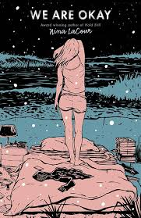
We Are Okay by Nina LaCour
Marin hasn’t spoken to anyone from her old life since the day she left everything behind. No one knows the truth about those final weeks. Not even her best friend, Mabel. But even thousands of miles away from the California coast, at college in New York, Marin still feels the pull of the life and tragedy she’s tried to outrun. Now, months later, alone in an emptied dorm for winter break, Marin waits. Mabel is coming to visit, and Marin will be forced to face everything that’s been left unsaid and finally confront the loneliness that has made a home in her heart.

Summer Reading Prompt

Write or type one 300-500 word essay in which you identify and support a claim about a character or theme in each book. Support your claim with valid reasons and evidence from the book.

In your writing make sure you:

- Write an introduction that engages the reader
- Organize your writing into logical paragraphs
- Clearly state your central idea or claim
- Give reasons for your central idea or claim
- Provide textual evidence to support your ideas
- Use transition words or phrases to connect your ideas
- Write a conclusion that summarizes your main points

PERTH AMBOY HIGH SCHOOL
300 Eagle Avenue ~ Perth Amboy, New Jersey 08861
732-376-6030 (voice) ~ 732-347-8930 (facsimile)

English IV Honors

The Year of the Flood by Margaret Atwood

The Poisonwood Bible by Barabara Kingslover

In order to prepare you for this year, you will be reading two novels: The Year of the Flood by Margaret Atwood and The Poisonwood Bible by Barbara Kingslover.

Writing Assignment
Type two essays in which you identify and support a claim pertaining to a theme in one book and a character in the other book. Support your claim with valid reasons and evidence from the book.

As you write, keep in the mind the following:
  - Make sure you use direct evidence, i.e. quotes, from each of the novels in your essay. Use quotes to support your arguments. When you use quotes, always reference the page number.
  - Do not start a paragraph with a quote from the novel(s).
  - Your paper should be at least 2 pages in length (12 point font and double-spaced)
  - Papers should be typed and hard copies must be submitted on the first day of school, unless told otherwise.

PERTH AMBOY HIGH SCHOOL
300 Eagle Avenue ~ Perth Amboy, New Jersey 08861 732-376-6030 (voice) ~ 732-347-8930 (facsimile)

AP Literature and Composition Summer Reading

Welcome to the AP English Literature and Composition. This course is an introductory college-level literary analysis course. The course engages you in the close reading and critical analysis of imaginative literature to deepen your understanding of the ways writers use language to provide both meaning and pleasure. As you read, you will consider a work’s structure, style, and themes, as well as its use of figurative language, imagery, symbolism, and tone. During the year, your writing assignments will include expository, analytical, and argumentative essays that require you to analyze and interpret literary works.
You are to read How to Read Literature Like a Professor by Thomas C. Foster, Jane Eyre by Charlotte Bronte and Wide Sargasso Sea by Jean Rhys. Foster’s work will serve as a companion text for our course reading throughout year starting with your summer reading. There are three tasks to be completed.

Task 1 – How to Read Literature Like a Professor by Thomas C. Foster

“The novels we read allow us to encounter possible persons, visions of ourselves that we would never see, never permit ourselves to become, in places we can never go and might not care to, while assuring that we get to return home again.”
—Thomas C. Foster

In order to prepare for the level of analysis required in a college-level literary analysis course, it is important that you build a background of foundational skills. Thomas C. Foster’s How to Read Literature Like a Professor does a good job of breaking down topics common in the study of literature. Providing a breadth of concise explanations of symbol, metaphor, allusion, and a variety of other topics, it is one of the single most useful texts for learning to approach works of literature with a critical eye. It will provide you with the Literary analysis skills and strategies that you use to analyze the parts (characters, plots, setting) that bring meaning to literature.

Your first task is to read this book, which the free PDF can be found at https://bit.ly/2hNd91B. Make sure you read the Revised Edition. ​Based on the reading, answer the corresponding questions for each chapter on Appendix 1. The embedded questions will help you track your developing understanding and serve as a resource for your analysis of two novel readings.

Appendix 1
How To Read Literature Like a Professor by Thomas C. Foster
Notation Suggestions and Practical Application
Chapter Title |  | Check For Understanding  (Upon Reading) | Challenge Yourself  (Throughout Your Literary Career)
Introduction: How’d He Do That? |  | How do memory, symbol, and pattern affect the reading of literature? How does the recognition of patterns make it easier to read complicated literature?
1 | Every Trip Is a Quest (Except When It’s Not) | What are the five aspects of the QUEST?
2 | Nice to Eat with You: Acts of Communion | How do authors use meals to convey meaning?
3 | Nice to Eat You: Acts of Vampires | What are the essentials of the Vampire story?
4 | Now, Where Have I Seen Her Before? | What is intertextuality? What are archetypes?
5 | When in Doubt, It’s from Shakespeare... | How does the concept of intertextuality relate to the works of Shakespeare?
6 | ...Or the Bible | What themes does Foster include in his discussion? To what Biblical stories does he allude?
7 | Hanseldee and Greteldum | Which myths and fairy tales does Foster relate to literature?
8 | It’s Greek to Me | Note characters or situations from Greek mythology. What claims does Foster make regarding myth?
9 | It’s More Than Just Rain or Snow | For what purposes is weather used in literary and cinematic works. Interlude Does He Mean That? What claims does Foster make about writers?
10 | Never Stand Next to the Hero | What is significant about Foster’s reminder that most of literature is “Character-Based?” What is the “surrogacy phenomenon” that Foster proposes? Why aren’t all characters round?
 | Interlude: Does He Mean That | What claims does Foster make about writers?
11 | ...More Than It’s Gonna Hurt You: Concerning Violence | What is Foster’s major claim regarding violence in literature? What are the two kinds of violence found in literature? What are their effects?
12 | Is That a Symbol? | How do symbol and allegory differ? What items do authors use as symbols?
13 | It’s All Political | Note criteria Foster uses to support the title of the chapter. Define “isms” Foster mentions.
14 | Yes, She’s a Christ Figure Too | Note criteria Foster uses to identify Christ figures in literature.
15 | Flights of Fancy | How do writers use flight to convey meaning in their works?
16  & 17 | It’s All About Sex… & ...Except the Sex | Except the Sex, What assertions does Foster make regarding sex scenes in literature?
18 | If She Comes Up, It’s Baptism | What are the plot implications of drowning (or not drowning)? What meaning might be conveyed through a “baptism scene”?
19 | Geography Matters… | How does Foster define geography? Why is it so important in literature?
20 | ...So Does Season | How do writers use the seasons in meaningful, traditional, or unusual ways?
 | Interlude: One Story | What argument does Foster repeat in this chapter and how does he support it?
21 | Marked for Greatness | What meaning do physical imperfections take on in literature?
22 | He’s Blind for a Reason, You Know | What must a writer do in order to introduce a blind character in a work? What can blindness symbolize in a work?
23 | It’s Never Just Heart Disease...And Rarely Just Illness | (Heart Disease) )What assertions does Foster make in order to support the title of this chapter? (Illness) According to Foster, what are the "principles governing the use of disease in literature"? Note their effectiveness as related to plot, theme, and symbolism.
24 | Don’t Read with Your Eyes | Focus on Foster’s remarks about specific assumptions that authors make given the time and place in which they write. What does he mean when he advises, “Don’t read with your eyes.”?
25 | It’s My Symbol and I’ll Cry If I Want To | What is a literary conceit and how and to what effect may writers employ them? How does creating a “common pool of figurative data over the centuries” allow for texts to mean more than one thing simultaneously? Why do readers need to be mindful of secondary and primary meaning in text? Why does Foster remind readers to simply “use what you know?”
26 | Is He Serious? And Other Ironies | What is meant by the “ironic mode”? What are the characteristics of irony? How and why do authors employ it? What is meant by the multivocal nature of irony in a work?
27 | A Test Case | Read “The Garden Party” by Katherine Mansfield, the short story starting on page 245. Read the exercise on pages 265-266, following the directions exactly. How would you respond? How did your ideas compare with the sample essay that follows. What does the essay that follows comparing Laura with Persephone add to your appreciation of Mansfield’s story?

Task 2 –Classic/Contemporary Literature Pairing: Jane Eyre and Wide Sargasso Sea
“What is past is prologue.”
—William Shakespeare, The Tempest

You are to read Charlotte Bronte’s literary classic, Jane Eyre followed by Jean Rhys’ postcolonial and revisionist rewrite, Wide Sargasso Sea. Reading these novels in sequence offers a wonderful opportunity to appreciate a classic and contemporary piece of literature while also exposing you to the intertextuality that exists in literary study.

*NOTE-TAKING: In order to get the most out of your reading (and make your fall assignments much easier), make sure you’re an active reader of these books. As you read, be sure to annotate for character/character development, conflict, theme, rhetorical devices/word choice, setting, and form/structure.

Task 3 –Reading (and Writing About) Literature Like a Professor: Companion Analysis
“The answers you get from literature depend on the questions you pose.”
—Margaret Atwood

In this assignment, you will be writing analytical responses connecting specific Foster chapters to your summer readings. You will complete four responses. Select two chapters from Foster’s book that you can apply to your analysis for each of the summer reading books. For example, you may select Chapters 13 and 25 and apply the ideas in your analysis of Jane Eyre but may use Chapters 16 and 24 to develop your response to Wide Sargasso Sea. Each companion analysis response will be graded on the following:

1. The relevance of how the Foster chapter you choose pairs with and extends your critical reading of assigned novel or its parts.
2. A deep, thoughtful analysis of the assigned reading that is tied closely to the subject and content of the Foster chapter. It must demonstrate a rich understanding of the Foster chapter you selected and how it applies to the novel under discussion.

Reminder: Literary analysis is the act of looking at how the parts of a text affect the meaning of the work as a whole: for example, how the characters, plot, and setting are used to create meaning in a piece of literature.

3. Limited summary of the selected Foster chapter and novel. Summary is to be used for the sole purpose
of providing context for the analysis.
4. Quotations from both the novel and Foster throughout response, with accurate page citations
5. Clear 12 point font, 1.15-1.5 line spacing, MLA header with word count (400-450 words)

Below is an example of what your analytical response may look like.
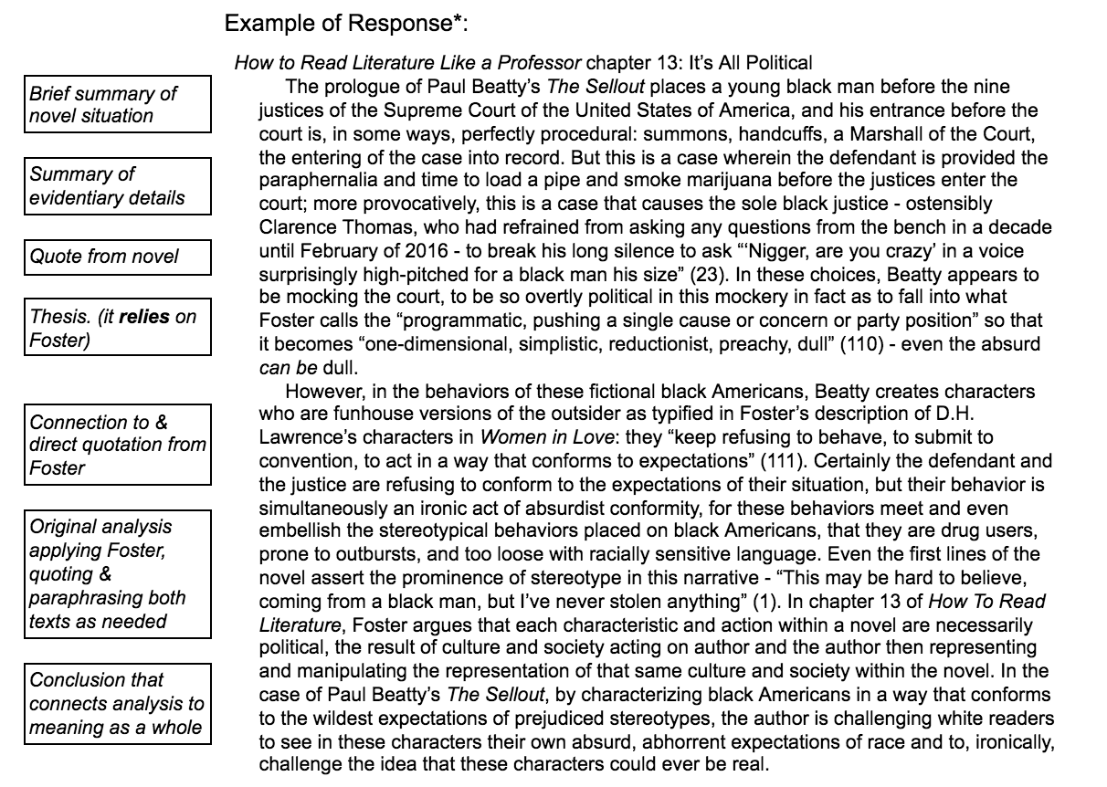

*Adapted from Wesley Lydon @lydonteaches.com

PERTH AMBOY HIGH SCHOOL
300 Eagle Avenue ~ Perth Amboy, New Jersey 08861 732-376-6030 (voice) ~ 732-347-8930 (facsimile)

AP Language and Composition Summer Assignment

Welcome to the AP Language and Composition course. This AP course is designed to help you with the skills you need to read, write and think at the college level. The course is organized thematically. You will “explore the complexities of a single issue and synthesize the different viewpoints represented.” Each interesting and relevant theme – Education, Gender, Politics, Popular Culture to name a few- is centered on an essential question that engages you to begin thinking critically. You will learn to read and analyze nonfiction, poetry, some fiction and visual texts for rhetorical concepts, diction and syntax. Through these readings, you will gain a stronger understanding of language and composition that will assist you with your own writing. You will learn to effectively utilize the writing process to develop multi-drafted essays that demonstrate your ability to analyze and synthesize information from a variety of thematic resources. In preparation for the course, you will have a 4-part summer assignment focusing on reading, and writing. All assignments will be collected at the beginning of the school year.

Assignment 1:

You must read the assigned book, How to Read Literature Like a Professor, by Thomas Foster.

Then complete the accompanying graphic organizer (Appendix A) and apply what you have learned from this text as you reflect on various sources.

Assignment 2:

Read The Autobiography of Malcolm X by Alex Haley and Malcolm X and write an essay that addresses the prompt below.

Prompt: In an essay, examine how each of the following sections helps contribute to Malcolm X’s attitude and views on race at different stages of his life.

1. Chapters 1-9: Using specific examples, discuss how Malcolm X struggled against
racism in his youth and how it affected his life choices in Boston and Harlem.
2. Chapters 10-11: Discuss the effects of prison life on Malcolm X.
3. Chapters 12-15: Discuss how Malcolm’s immersion into the religion of Islam affected
his attitudes about race.
4. Chapters 16-end: Discuss how Malcolm’s inner spiritual quest changed his views on
racism.

Assignment 3:

1. On https://www.americanrhetoric.com select the following speeches:
- Malcolm X’s speech titled: The Ballot or the Bullet
- Martin Luther King’s speech titled: I Have a Dream speech
2. Read both speeches and use the D.I.D.L.S. graphic organizer(Appendix B) to present your analysis of the speech. Complete a separate organizer for each speech.

Assignment 4:

After reading the two speeches and completing both D.I.D.L.S graphic organizers, write a comparison/contrast essay comparing and contrasting the rhetorical devices (diction, structure, strategies, etc.) each speaker uses to deliver his message.

Appendix A

How to Read Literature Like a Professor chapter | Connection to your novel, movie, tv show, etc.
Chapter 14- “Yes, She’s a Christ Figure, Too” | Old Man and the Sea  When Santiago takes his voyage, he undergoes great physical suffering: his hands are slashed, he has a pain in his side, and he endures for three days. His return is like a resurrection and carries his mast which resembles a man carrying a cross. The next day even the doubters have faith in his ability again.

Directions: Apply what you have read in Reading Literature Like a Professor to other works of fiction you’ve encountered. In the main box of the organizer, explain the connections you made between the Foster reading and your piece of fiction.

How to Read Literature Like a Professor chapter | Connection to your novel, movie, tv show, etc.
Chapter 1- “Every Trip is a Quest (Except When It’s Not)”

Chapter 2- “Nice to Eat with You: Acts of Communion”

Chapter 3- “Nice to Eat You: Acts of Vampires”

Chapter 10- “It’s More Than Just Rain or Snow”

Chapter 11- “... More Than It’s Gonna Hurt You: Concerning Violence”

Chapter 12- “Is That a Symbol?”

Chapter 14- “Yes, She’s a Christ Figure, Too”

Chapter 18- “If She Comes Up, It’s Baptism”

Chapter 21- “Marked for Greatness”
Chapter 22- “He’s Blind for a Reason, You Know”

Appendix B

Malcolm X- “The Ballot or the Bullet”
Diction
- What words does the author choose?
- Why does the author choose these specific words?
- What are the connotations associated with that choice?
Imagery
- What images does the author use?
- What senses does the author appeal to?
- What does the author’s use of images tell you about
his/her writing style?
Details
- What facts does the author include?
- What facts does the author exclude?
- Why does the author include or exclude these details?
Language
- What is the overall impression of the language the
author uses?
- Does the language reflect a certain level of education or
a particular profession?
- What style does the language convey?
Structure
- How is the format of the text organized?
- How are the sentences written?
- What impression does the structure give?

Dr. Martin Luther King Jr.- “I Have a Dream”
Diction
- What words does the author choose?
- Why does the author choose these specific words?
- What are the connotations associated with that choice?
Imagery
- What images does the author use?
- What senses does the author appeal to?
- What does the author’s use of images tell you about
his/her writing style?
Details
- What facts does the author include?
- What facts does the author exclude?
- Why does the author include or exclude these details?
Language
- What is the overall impression of the language the
author uses?
- Does the language reflect a certain level of education or
a particular profession?
- What style does the language convey?
Structure
- How is the format of the text organized?
- How are the sentences written?
- What impression does the structure give?

PERTH AMBOY HIGH SCHOOL
300 Eagle Avenue ~ Perth Amboy, New Jersey 08861
732-376-6030 (voice) ~ 732-347-8930 (facsimile)

ESL (English as a Second Language) Summer Reading Assignment

Welcome to ESL Levels 1-4! In order to prepare for the upcoming year, you should read one of the novels listed below in its entirety. In addition to reading your chosen novel, you are encouraged to complete a Double Entry Journal. You will use the journal in September to complete a writing assignment for your ESL class.

Level 1: Who’s Got Game? The Lion or the Mouse? by Toni & Slade Morrison
Any Small Goodness by Tony Johnston
Level 2: Facing the Lion by Joseph Lemasolai Lekuton
Finding Miracles by Julia Alvarez
Level 3: The Forbidden Schoolhouse by Suzanne Jurmain
Romiette and Julio by Sharon M. Draper

Level 4: Necessary Roughness by Marie G. Lee
Speak by Laurie Halse Anderson

Double Entry Journal - For your chosen novel, you will complete a double entry journal. You must identify and analyze parts of the novel that are significant to you.
- Use the attached format for your double entry journal.
- Cite each quotation properly (author’s last name and page number).
- You may use your entries in order to complete a writing task upon your return in September. • EXTRA CREDIT will be given for completed work.

***If you enjoy reading, many novels (in English and Spanish) are available at the Perth Amboy Public Library (196 Jefferson Avenue).***

Start reading and have a wonderful summer!

Double Entry Journal
Name:____________________________________________________ Date:________________________
Text Title: Author:
WHAT THE AUTHOR WROTE…

Text
(
Reference/Quote)

In the space below,
copy from the text

direct
quotations, key words, details, and/or summaries
that capture your attention. This is a
quote
.
Be sure
to include the author’s last name followed by the
page number in parentheses.

EX: (Alvarez
, 60).

WHAT I THINK…

)
Your Opinion or Interpretation
(

Write a
response to the quote

including:

. Context: What is happening at this point in the
1
novel?

2
. Summary: What does the quote mean?

3
. Significance: Why is the quote important?

Summary Write a short summary of your observations above and explain the main idea or theme of the passage.

