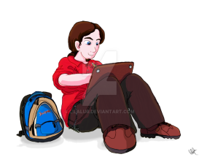**PAHS Athletic Study Hall/Learning Center Make-Up Hours**

|  |  |
| --- | --- |
| Name of student: | Sport: |
| Date: | Location of session: |
| Time started: | Time ended: |
| Teacher/Librarian signature: | Comments |



Please return form to either your coach or Ms. Riggins