**PAHS Athletic Study Hall/Learning Center Hours** 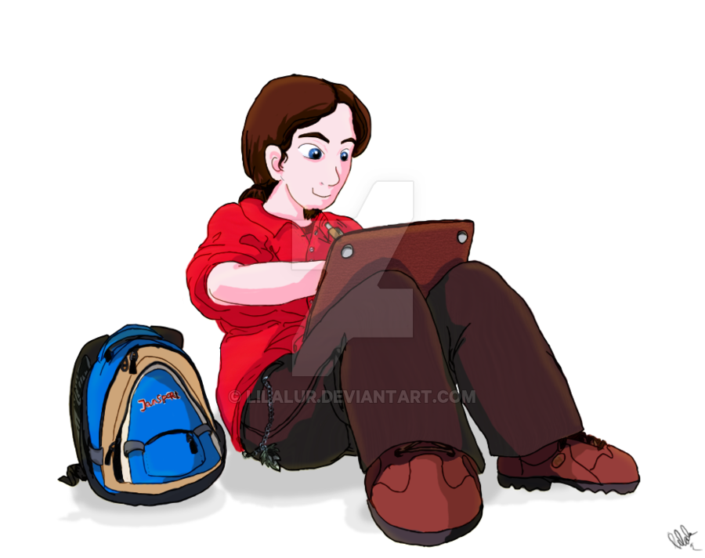

*Please fill out all requested information*

|  |  |
| --- | --- |
| Name of student: | Sport: |
| Date: | Location of session: |
| Time started: | Time ended: |
| Teacher/Librarian signature: | Reason for hours:  *If this is for make up hours, include the date(s) you missed.* |

Please return form to either your coach or Ms. Riggins

