Perth Amboy Public Schools



Middlesex County

District

Novice Mentor Teacher Training Plan

2020-2021

Submitted by:

Perth Amboy Public School District

District Mentor Team

Mr. Delvis Rodriguez, Assistant Superintendent of Administration  
Dr. Vivian Rodriguez, Assistant Superintendent of Curriculum and Instruction  
Dr. Damian Medina, District Director of Curriculum & Instruction  
Mr. Michael Heidelberg, Principal  
Ms. Joanna Joaquin, Vice Principal  
Ms. Lauren Marrocco, Principal



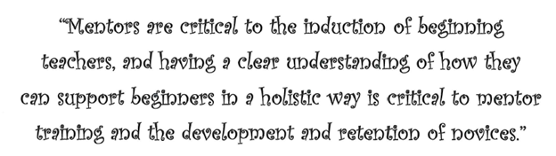

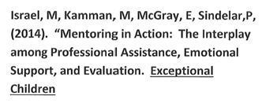



Table of Contents

1) Vision and Goals

2) Mentor Selection and Training

3) Mentor Training / Novice Teacher Training

4) Domains

5) Mentoring Duration Requirements

6) Mentor and Novice Teacher Roles and Responsibilities

7) Action Plan Implementation

8) Appendix A: PAPS Declaration to Intent to Mentor Form

9) Appendix B: Mentor Selection Checklist

10) Appendix C: Mentor Log Form

11) Appendix D: Novice Teacher Log

12) 2020-2021 Perth Amboy Mentor / Mentee Survey

Vision and Goals

The Perth Amboy School District Mentee / Mentor Teacher Training Plan aims to create a collaborative and supportive environment that supports academic excellence, highly effective professional staff, and the reduction of new teacher attrition.

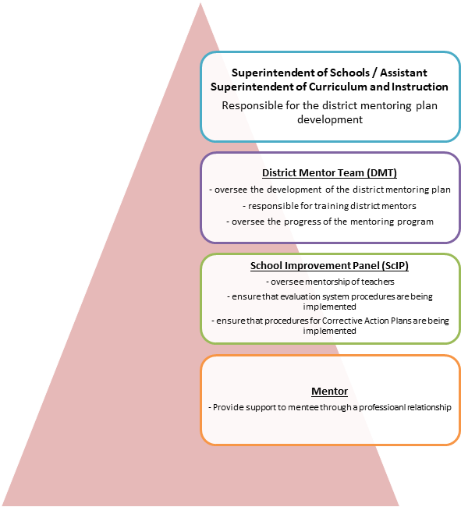

**  
Mentor Selection**

**Mentor Criteria**  
 An internal posting will be publicized in each school

All teachers will be able to apply to be considered as a mentor if they:

* Demonstrate a record of success in the classroom
* Have earned a summative rating of highly effective or effective on most   
   recent summative evaluation
* Must be tenured in Perth Amboy School District
* Understand and demonstrate the norms of the district, school, and  
  Community
* Demonstrate participation in a professional school community
* Understand resources and opportunities available and is able to act as a referral source

**Mentoring Selection Process**:  
The District Mentor Team in conjunction with building Principal / Directors screens and  
selects the best qualified teachers that apply to be mentors  
 Institutional review of Mentors by Superintendent of Schools  
Board Approval of Mentors  
Training of Mentors remotely (Zoom, virtual training, online)



**Mentor Training**

**Mentor Training**:

Mentors are required to attend an in-depth training session (Online, remotely, virtual training). A Mentor Handbook is provided to support ongoing mentoring efforts. Training includes:

* The NJ Professional Standards for Teachers
* Classroom observation skills
* Leading reflective conversations about practice
* Thorough working knowledge of the Danielson Framework and its application within   
   the district’s evaluation system

**Mentee Training**:  
Mentees entering their first year of teaching are required to participate in a formal mentoring program (online, remotely, virtual training) over the course of their first year of teaching and additional content training sessions. All new staff must attend New Staff Orientation. Learning components of New Staff Orientation and the first two professional development days include:

* Introduction to the district community (remotely)
* New evaluation system training (online training)
* Curriculum training aligned to the NJ Student Learning Standards
* Mandated policy training
* Project Day

**The Danielson Framework for Teaching**

|  |  |
| --- | --- |
| **Domain 1: Planning and Preparation** | **Domain 2: Classroom Environment** |
| a. Demonstrating knowledge of content and pedagogy  b. Demonstrating knowledge of students  c. Setting instructional outcomes  d. Demonstrating knowledge of resources  e. Designing coherent instruction  f. Designing student assessments | a. Creating an environment of respect and rapport  b. Establishing a culture for learning  c. Managing classroom procedures  d. Managing student behavior  e. Organizing Physical Space |
| **Domain 3: Instruction** | **Domain 4: Professional Responsibilities** |
| a. Communicating with students  b. Using questioning and discussion techniques  c. Engaging students in learning  d. Using assessment in instruction  e. Demonstrating flexibility and responsiveness | a. Reflecting on Teaching  b. Maintaining Accurate Records  c. Communicating with Families  d. Participating in a professional community  e. Growing and developing professionally  f. Showing professionalism |

**Mentoring Duration Requirements**

District boards of education must provide one-to-one mentoring support to novice provisional teachers for the first year of their employment, which is defined as a minimum of 30 weeks.

The mentor teacher and the mentee holding a Certificate of Eligibility with Advanced Standing (CEAS) or a Certificate of Eligibility (CE) must meet at least once per week.

One-to-one mentoring that includes planned, remotely between the mentor teacher and the provisional teacher holding a CE or EAS must occur over the course of the academic year (a minimum of 30 weeks), or proportionally longer if the novice provisional teacher holds a part-time teaching assignment.

One full hour of uninterrupted mentor / mentee meeting before or after school

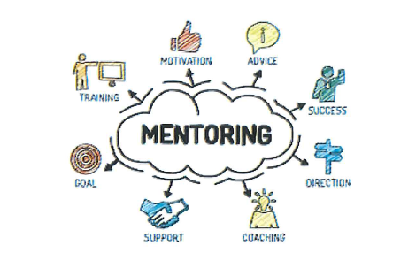

**Roles and responsibilities:**

The following roles and responsibilities were established by former district mentors and novice teacher after reflecting upon their experiences together:

* Collaborate with your assigned mentor
* Participate in all training sessions designed for novice teachers throughout   
   the year.
* Develop a plan for meeting with your mentor teacher, meeting on a regular   
   basis.
* Take the Beginning, Middle, and End of the Year Teacher Self-Assessment   
   and share with mentor.
* Collaborate with your mentor to maintain a log of weekly meetings
* Observe your mentor teacher and other effective teachers in your school   
   or those within district.
* Utilize the expertise of supervisors, instructional leaders and building   
   principals.
* Model a spirit of professionalism
* Seek out your mentor for answers to questions that may arise
* Attend End of Year-Project Day Celebration

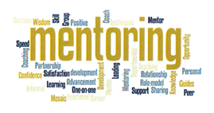

**  
Action Plan Implementation   
Yearly Mentor Action Plan / Implementation**

|  |  |
| --- | --- |
| **Date** | **Description** |
| August | Mentor Selection and Training (online) |
| August | Update the Mentor Plan Handbook and contract to meet ACHIEVENJ regulations |
| August | District Mentor Trainer meeting to update committee responsibilities and plan for mentor training |
| August | New Teacher Orientation and Professional Development |
| October | Mentoring Training |
| Quarterly | Mentor support Meeting with Principals |
| Quarterly | Mentee support meeting with Principals |
| December | Mentoring committee meeting to review evaluation of Mentee |
| January | Meeting with Principals to review evaluations and recommendations for non-renewal/additional supports needed for Mentees |
| March | Peer support group meeting  (Mentors and Mentees) |
| April | Mentor/Mentee Survey |
| May | End of year Mentor/Mentee Project Day |
| June | Mentor Selection and Training for  2020-2021 school year |



**Declaration of Intent to Mentor**

I, _______________________, accept the assignment as Mentor for _______________ at the _______________________ during the period of __________ to ________________ at a stipend of ________________ as articulated in the contract for the 2020-2021 school year. I understand and accept the following responsibilities:

To attend mentor workshops required by the district,

To relinquish one hour of time per week to formally confer with my mentee as well as making myself accessible on an informal basis during times which are outside my contractual working time (before school or after school, meeting during lunch and prep not permitted),

To document the conference time, I give to the mentee as to date duration, and topics discussed,

To apprise my mentee of district and school procedures and policies,

To provide support and guidance to my mentee through the year in the areas of management, instruction, and resources,

To encourage continuous learning,

To demonstrate high standards and work ethics that promotes excellence in teaching,

To respect the confidential nature of the mentor / mentee relationship.

Mentor’s Signature:__________________

Date: _____________________________________



Mentor’s Checklist

At the outset of a school year mentees are often overwhelmed with a large set of questions that the experienced teacher takes for granted: How do I set up a grade book? How do I get things photocopied? Where is the nurse’s office/ teacher’s lunch room / music room / gym, etc. How do I access student supplies (paper/pencils, computer ink, computer log in, etc.)? When / where are common planning / grade level meetings? It is important for mentors to anticipate and address these concerns. Below is a checklist of basics that a mentee must know in order to function smoothly.

Beginning Items:

* Setup classroom
* Cumulative folders
* Class lists
* Where to find student textbooks
* Teacher Manuals
* How to get additional student desks/chairs
* Where to park
* Dress Code
* Room/building keys
* Use of copy machines
* Ordering/obtaining supplies
* Resources materials (leveled books/math manipulatives)
* School calendar
* Arriving late or early
* Obtaining a substitute teacher
* Staff handbook
* Hall passes
* Outgoing mail
* Inter-school mail

Locations:

* Overview of school layout
* Main Office
* Restrooms
* Counselor’s Office
* Media center and conference rooms
* Nurse’s Office
* Social worker/crisis counselor’s office
* Special education rooms
* Computer labs
* Playground access
* Lost and found
* First aid supplies

Staff:

* Administrators / supervisors
* Grade level/department teachers
* Secretaries
* Psychologist
* Counselors
* Social Worker
* Custodians
* Security
* Kitchen/lunch staff
* Paraprofessionals
* Professionalism-if you have a problem, tell someone. Learn who to ask for help.
* Teacher issues-communicate with administrators

Procedure:

* Assembly responsibilities
* Bus/hall duty
* Access to phone
* Voicemail/email
* Long distance calls
* Visitors at work
* Lesson plans
* Computer use
* Library use
* Checking voicemail
* Checking email
* Emergency action/lockdown plan

Settling In:

* School happenings
* Field trips
* Visitors in hallway
* Reporting abuse/DYFS
* Child study meetings
* Attendance
* Announcements
* Tornado/fire drill/early closings/inclement weather closing/late   
   openings
* Bomb threats
* End of period/day dismissal
* Tardiness
* Accidents
* Fighting
* Faculty meetings/building committees
* Safety issues for teachers
* Health issues w/students in the classrooms  
   (fainting/vomiting/seizure/medications/etc.)

Curriculum/Grading:

* Define department/grade level curricula
* Location materials to support curriculum
* Setting up grade book
* Midterm grading procedures
* Grading policies and reports
* Grade level grading criteria
* Grade level benchmark assessments

Parent Contact:

* Open house
* Music/Gym programs
* Parent/Teacher Conferences-Professionalism-what to say and what   
   not to say-the conference is about the student
* Calling parents
* Documentation of parent contact
* Positive/complimentary notes/cards
* Sending information/newsletters home

Teacher Needs:

* District salary guide lane changes
* Procedure for graduate course application
* Licensure
* Union meetings
* Union building representatives
* Contract negotiations
* Sick Leave
* Personal Leave
* Bereavement Leave
* Emergency absence
* Grievance procedures
* Evaluation procedures
* Professional development-how to apply for workshops
* Building staff procedures
* How to communicate with administration
* What to do if a teacher is injured by a student

End of Year:

* Final benchmark / end of course tests
* Final grades and reports
* Permanent record cumulative folders
* Sort and organize personal materials
* Return building and district materials
* Building inventories
* Year-End checklists

Items to be submitted:

* Frontline-Professional Growth – Mentor Logs/Mentee Log



