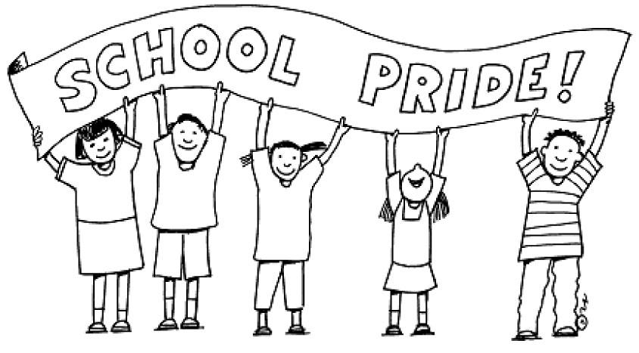 | September/October 2023  Class News  From the 5th grade classroom of Ms. Buonomo

Highlights
Welcome back to school and to 5th grade at E.J. Patten School. We are having an exciting and busy month of September, reviewing procedures, and getting to know each other. Now that the first full week is behind us, we will be getting right into Reading! Please check my page on the Patten website for all information: https://www.paps.net/Page/18011If you need to contact me, please e-mail us anytime! (Terebuonomo@paps.net) The team website is https://sites.google.com/paps.net/msbuonomo-2020-2021/home
.   September:  7 - Adys Rosario Diaz  27 - Aleysha Reyes Cepeda  October:  29 - Chris Correa  Important Dates  - September 19, 2023 – Back to School Night  - October 11, 2023 – Progress Reports  - October 25 & 26 – Parent/Teacher Conferences |  | Subject news
Reading: We are working on plot, context clues, and developing vocabulary. We use the Reading Workshop model in 5th grade. Students will be selecting their own books and should be reading nightly. Reading logs and responses will be expected nightly Monday – Thursday.
Specials
Monday – Health
Tuesday – Music
Wednesday – Gym
Thursday – Gym and Technology/Media
Friday - Art

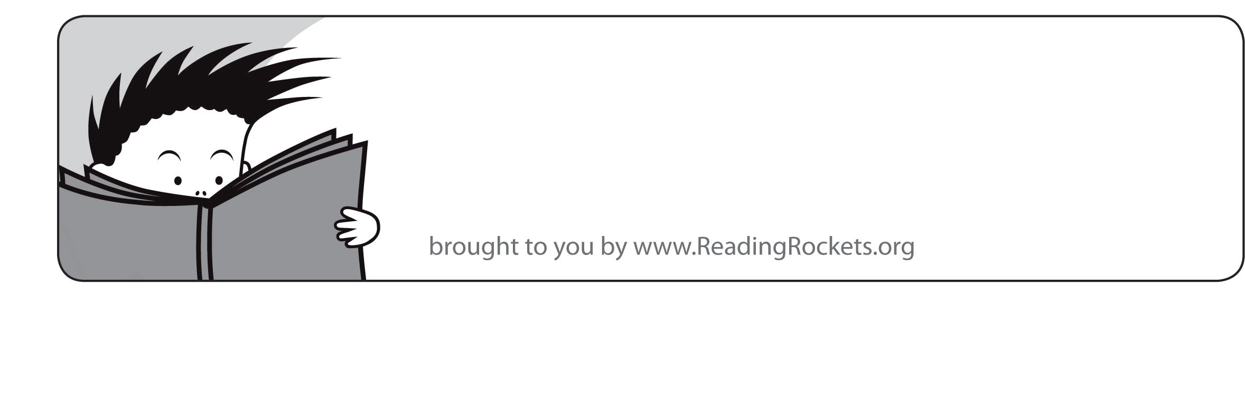

Something to talk about. Reading doesn’t have to stop when you put the book down. Talk to your child about books you’ve read and books you think he or she might enjoy. Please make sure your child is reading 60 minutes a week and logging his/her reading log.

Reading tip of the week...

